Missouri House of Representatives

Report of the
Interim Committee
on Early Voting

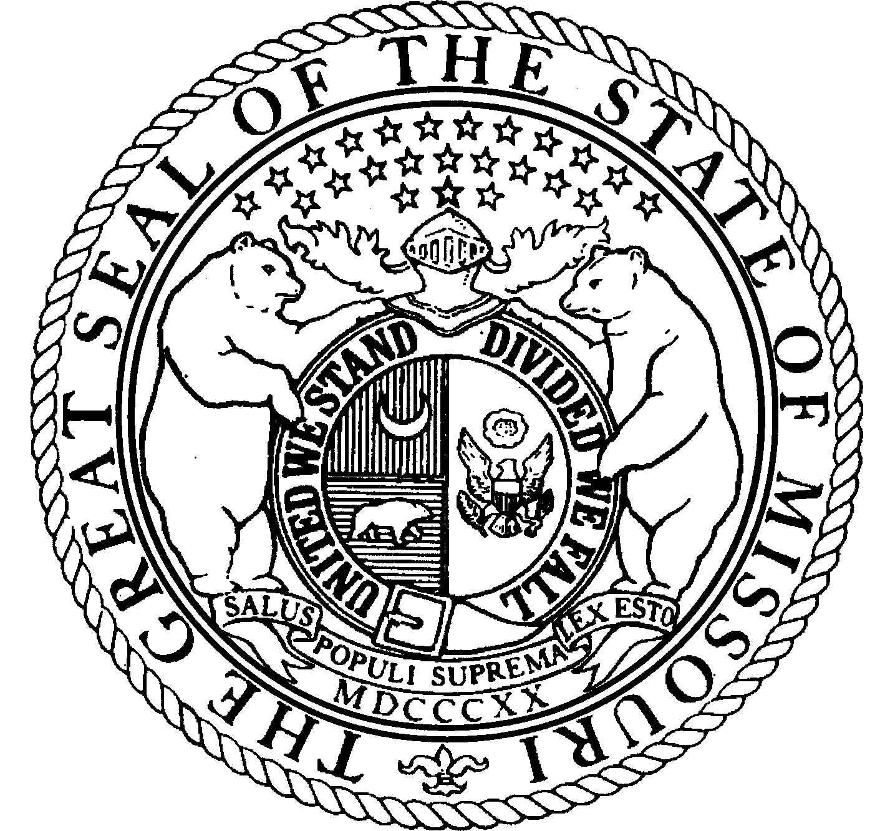

January 2005

Prepared By:
Julie Jinkens McNitt, House Research

January 25, 2005

The Honorable Rod Jetton, Speaker
Missouri House of Representatives
State Capitol Building
Jefferson City, MO 65101

Dear Mr. Speaker:

The Interim Committee on Early Voting, acting pursuant to the request of former Speaker Hanaway, has met, taken testimony, deliberated, and concluded its investigation of early voting and no-excuse absentee voting in Missouri. On behalf of the committee members, we are pleased to submit the attached report.

Sincerely,

Rep. Bill Deeken
Committee Co-Chair

Rep. Tom Villa
Committee Co-Chair

INTRODUCTION

Speaker of the House, Rep. Catherine Hanaway, appointed the House Interim Committee on Early Voting in September 2004. The committee consisted of:

Rep. Bill Deeken, Co-Chairman
Rep. Tom Villa, Co-Chairman

Rep. Jack Goodman Rep. Brian Yates
Rep. Allen Icet Rep. Yaphett El-Amin
Rep. Scott Lipke Rep. Connie Johnson
Rep. David Pearce Rep. Jim Whorton

The committee was charged with reviewing the previously mandated plans for early voting by local election authorities and investigating no-excuse absentee voting to determine whether the state should implement early voting and/or no-excuse absentee voting, in what manner an early voting and/or no-excuse absentee voting period could be implemented most fairly, effectively and efficiently statewide, and the funding requirements for local election authorities to achieve this implementation. The committee was also charged with making recommendations to the legislature for changes to the law or for additional funding based upon its findings.

The committee held public hearings, at which oral and written testimony was presented, at the following locations:

Jefferson City October 13, 2004
Osage Beach November 23, 2004
Jefferson City December 3, 2004.

EARLY VOTING OVERVIEW

Early voting perhaps is best thought of as an umbrella term. It may connote an entirely different voting procedure in different jurisdictions: no-excuse absentee voting; in person no-excuse absentee voting; or advance voting. The one element these different voting procedures all have in common is that generally they are completed prior to election day, in a statutorily-defined early voting period. This overview will attempt to explain the differences briefly and in general terms.

Absentee voting generally is conducted by mail: the voter applies for an absentee ballot, the election authority mails the voter an absentee ballot, and the voter then returns the sealed, voted ballot to the election authority. Traditionally, absentee voting has been permitted only in a statutorily limited number of circumstances, such as the voter being out of the jurisdiction on election day. No-excuse absentee voting is exactly what it implies: the voter need not state a reason for wishing to vote by absentee ballot. In all other respects, no-excuse absentee voting is conducted exactly like regular absentee voting.

When the no-excuse absentee ballot is requested and cast in the election authority’s office, the procedure may be referred to as in person no-excuse absentee voting.

Advance voting is done in person as well, either in the election authority’s office or a satellite location, if authorized. The voted ballot, however, is placed directly in a ballot box.

When the term early voting is used in this report, it will refer collectively to the two procedures described above in which the ballot is voted in the election authority’s office.

BACKGROUND

Missouri has only one statute dealing with an early voting process, section 115.126, and this section pertains to advance voting. See Appendix A. Because section 115.126 does not actually authorize early voting in Missouri, it will greatly aid the context of the Committee’s work to briefly discuss the legislative history of the bill that enacted this section in 2002.

Senate Substitute for Senate Committee Substitute for Senate Bill 675, the version of the bill sent to the House (hereafter the Senate version), authorized advance voting at the office of the election authority and up to four other polling places for a period beginning fourteen days prior to a general election in presidential election years and ending at 5:00 p.m. on the Wednesday before the election. The costs of implementing advance voting were to be paid by state appropriations. Election authorities were to submit funding requests to the Secretary of State by August 1st of each year. The Secretary of State would then submit the total funding request to the governor. If sufficient funds were not appropriated to pay the costs of advance voting and other financial obligations owed by the state to election authorities, advance voting would not occur.

The House Elections Committee removed the provisions requiring the state to pay other state obligations owed to election authorities prior to implementing advance voting, but otherwise the bill remained intact. On the floor of the House, however, the bill was changed to require only that election authorities submit a plan to implement advance voting as previously outlined to the Secretary of State by December 31, 2002. The total costs estimated by these plans to implement early voting, $2,435,699, was detailed in a report from the Secretary of State’s office in early 2003. See Appendix B.

SUMMARY OF PUBLIC HEARING ACTIVITY

October 13, 2004

The committee met to organize and set a hearing schedule. Glenda Mott, Laclede County Clerk, and Darrell Kempf, Cooper County Clerk, were in attendance and invited the committee to hold a hearing at the Missouri Association of Counties’ annual meeting at the Lake of the Ozarks on November 23rd. Because many county clerks and election authorities would be present and able to give their input and testimony, the committee agreed to hold the next hearing at that time.

Chuck Pryor, legislative liaison for the Secretary of State’s Office, advised the committee of the early voting cost estimates in the 2003 Secretary of State report, and offered to provide each of the committee members with a copy. Mr. Pryor indicated that Secretary of State Matt Blunt supported early voting. Mr. Pryor also briefly reviewed the procedural history of Senate Bill No. 675, as set out above.

November 23, 2004

After a few opening remarks by Secretary of State-Elect Robin Carnahan, Chairman Deeken opened the floor to public testimony. A significant number of the county election authorities present offered oral and/or written testimony and comments.

There were two main issues that almost every witness stressed to the committee:

* Early voting should not be mandated if not funded by the state.

* The cost estimates indicated in the election authority plans required in
2002 are now outdated and should be updated.

Other issues, concerns, suggestions and recommendations that were raised by the testimony included the following:

* Studies of early voting in other states indicate that it does not increase voter turnout, but does increase convenience and flexibility for voters.

* Early voting is a national trend, with at least 30 states now implementing some form of early voting.

* Because so many people currently lie in order to vote absentee, early voting would increase the fairness to all voters.

* If early voting is implemented in Missouri, some clerks would prefer that the number of possible satellite voting locations be mandated by statute (perhaps determined by a population-based formula) in order to decrease pressure on county clerks.

* If early voting is implemented, the time frame within which it is conducted should not start too early (in order to decrease the added workload for election authorities and their staff) and should end early enough to allow election authorities and their staff to update voter records so that no one may vote more than once.

* Early voting should be implemented only for statewide general elections, or only for federal elections.

* Missouri’s voting day should be shortened from thirteen hours to twelve hours.

* Pilot projects should be implemented around the state before statewide early voting is mandated.

* Early voting utilizing the sealed ballot (similar to absentee voting) would be more costly in terms of staff time than a method utilizing a ballot box.

December 3, 2004

Because no one came forth to testify at this public hearing, and because the committee had received so much input at the prior hearing, the hearing became the final working meeting of the committee and it was decided that no more hearings would be necessary. Committee members were asked to submit their comments, suggestions and recommendations to Chairman Deeken. The overall sentiment of the committee members who submitted opinions after the working meeting was:

The cost estimates indicated in the election authority plans required in 2002 are now outdated. Without current cost figures, it is difficult to analyze the costs versus the benefits of early voting at this time. The election authority plans should be updated.

It would not be fair to the already overburdened and underfunded counties to shoulder the full cost of implementing early voting.

It may not be in the best public interest right now, given the estimated costs of early voting (which figures are not even current) and the strained state budget, to spend the money to implement early voting when all indications are that it does not increase voter turnout and only increases convenience to voters.

CONCLUSION

The committee does not anticipate proposing any legislation at this time.

Appendix A

115.126. 1. Notwithstanding any provision of this chapter to the contrary, election authorities shall establish a plan to implement an advance voting period when eligible registered voters may vote before any general election in presidential election years at the office of the election authority and up to four other polling places designated by and under the control of the election authority. Such plan shall provide that the permissible advance voting period shall begin fourteen days prior to such election and end at 5:00 p.m. on the Wednesday before the day of such election.
2. Election authorities shall, pursuant to subsection 1 of this section, establish in their plans the hours and locations for advance voting. The election authority shall have all advance voting locations open on all business days during the advance voting period, and may have all advance voting locations open on Saturdays, Sundays and holidays during the advance voting period.
3. Except as provided in this section, advance voting procedures shall be conducted pursuant to sections 115.407 to 115.445. The secretary of state shall design the necessary application for use in an advance voting program pursuant to this section. All election authorities in this state shall submit to the secretary of state a plan to implement the advance voting period by December 31, 2002. The secretary of state shall assist election authorities in developing a plan for the implementation of an advance voting program.
4. The plans established pursuant to this section shall also require that before the precinct registers are delivered to the polling places for an election, the election authority shall record in the precinct registers the names of all voters who have submitted an advance voting ballot. The election judge shall not allow any person who has voted an advance voting ballot in the election to vote at the polls on election day. If it is determined that any voter submitted an advance voting ballot and voted at the polls on election day, such person, having voted more than once, is guilty of a class one election offense pursuant to subdivision (2) of section 115.631.
5. The secretary of state may promulgate rules to effectuate the provisions of this section.
6. Any rule or portion of a rule, as that term is defined in section 536.010, RSMo, that is created under the authority delegated in this section shall become effective only if it complies with and is subject to all of the provisions of chapter 536, RSMo, and, if applicable, section 536.028, RSMo. This section and chapter 536, RSMo, are nonseverable and if any of the powers vested with the general assembly pursuant to chapter 536, RSMo, to review, to delay the effective date or to disapprove and annul a rule are subsequently held unconstitutional, then the grant of rulemaking authority and any rule proposed or adopted after August 28, 2002, shall be invalid and void.

(L. 2002 S.B. 675)

Appendix B

